16.59: a) From Eq. (15.35), with m the mass of the string and M the suspended mass,

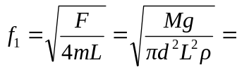
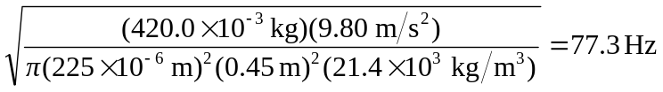

and the tuning fork frequencies for which the fork would vibrate are integer multiples of 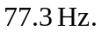 b) The ratio 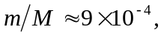 so the tension does not vary appreciably along the string.

